**CURRICULUM VITA**

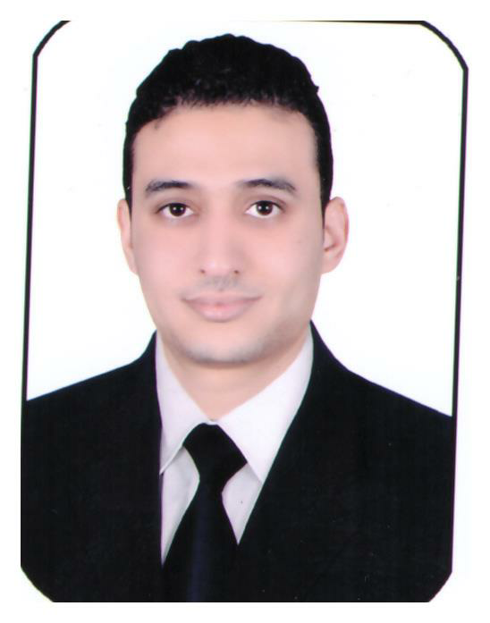

**1- PERSONAL INFORMATION ( DETAILS ) :**

**NAME :** Moataz Tharwat Ahmed Al Bably

**HOME ADDRESS :** Kafr Elzayat - El Gharbya-Egypt

**Date Of Birth : 29-04-1991**

**TELEPHONE :** Bahrain 00973/66911320

**E-MAIL :** Moatazalbably@Gmail.com

**2- EDUCATION:**

I Graduated From faculty of Commerce

Management Information Systems

Period Of 2012

**3-WORK EXPERIENCE :**

**Dates Company's name Position**

12-2012 till 10-2013 Amlak Real estate investment Sales Officer

11-2013 till 12-2014 Carta Paper Manufacturing Company Accountant 01-2015 till 11-2017 Alexandria Road Construction Company Accountant 12-2017 till now Alsufrah Althahabiah Restarunt Cashier

**4- LANGUAGE :**

**Arabic :** Native Language

**English:** Second Language

**5- ADDITIONAL SKILLS:**

I Have Certificates In ( Complaint Handling – Telephone Handling – Interaction – Delighting The Customer - OZ Principle ).

Experienced PC user( Excel, Word, Internet Access, Special accounting computer program, QuickBooks & Invo System ).

Many Years Experience Of Job With Office Equipment : Fax, copying machine, printers, etc.

**6- personal skills :**

* Knowledge and understanding of current developments and hospitality,
* Very Good Communication Skills and Leadership
* Very Good in Fast Learning and Development
* Hard Team worker
* Ability of Working under stress.

7- Duties & Responsibilities :

* Ability to store and work
* Audit of outgoing and incoming stores and daily restrictions
* Making suppliers and wages entitlements
* Preparation of the financial position statement
* Deliver and review the custody of purchases
* Contribute to the preparation of the budget and financial position of the company for 2015-2016

**8**- **CHARACTER :**

I have robust and energetic character, I am associable, intellectual, honest, kind and polite person

I am fastly acquired new experience knowledge, responsibilities.

**References:**

Mohamed Saber Tel:- 33340388 supervisor Alsufrah Althahbiya in Bahrain

**I hope my qualifications meet your requirement and allow me the opportunity**

**For interview,**

**I hope to join your great team ……**

**Thank You.**